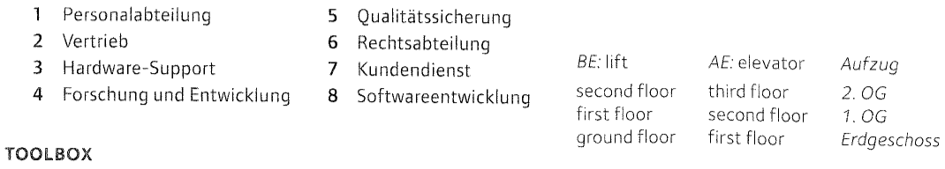

1. Human Resources Department
2. Marketing (distribution) Sales & Marketing
3. Hardware-Support
4. Research and Development
5. Quality Assurance
6. Legal Department
7. Customer Service
8. Software Development

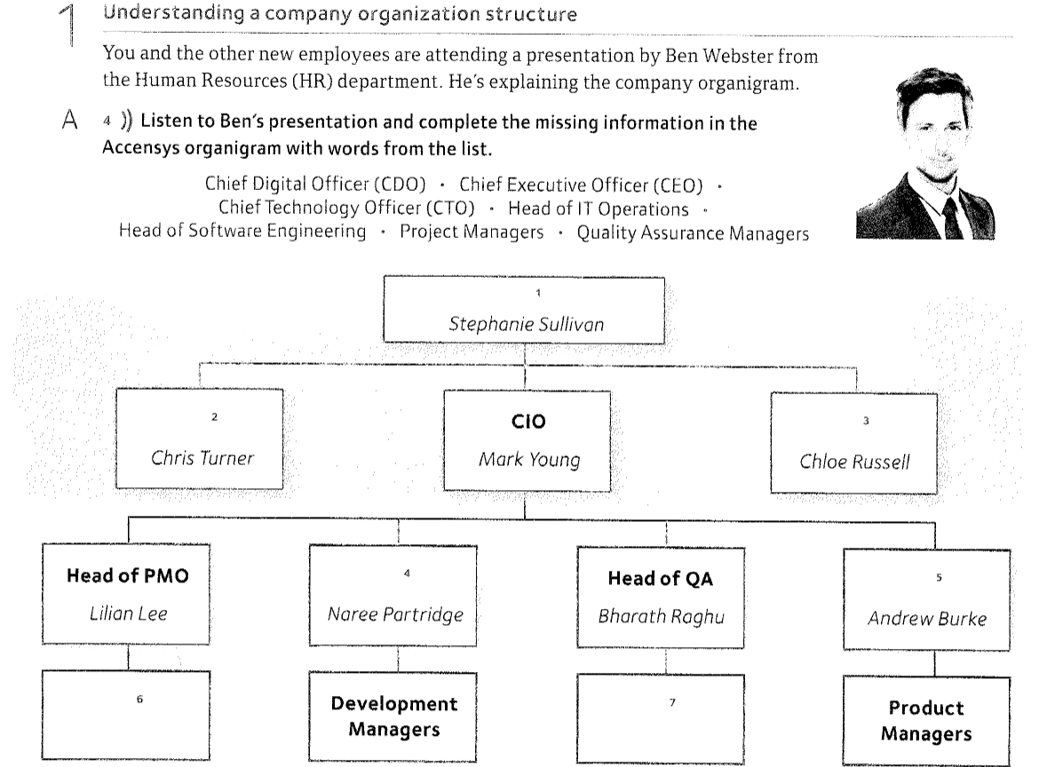

CEO – Sullivan

CIO – Mark Young

CTO – Chris Turner

CDO – Chloe Russell

PMO – Lilian Lee Project Management Operations

Project Managers

HSE -Naree Patridge

Development Managers

Head of QA – Bharath Raghu

Quality Assurance Managers / testing teams

Head of IT-Operation – Andrew Burke

Product Managers

Ein Bild, das Text enthält.

1 responsibilitys 2 goals

3 system 4 data

5 Technology 6 clients

7 software 8 projects

9 testing 10 products

11 hardware 12 platforms

Ein Bild, das Text enthält.

2 report to 3 manages 4 liaise with 5 is in charge of 6 report to 7 assist